Furniture Superclass

Bed and Table Subclasses

FurnitureGallery class

4 classes total

BASE CLASS – FURNITURE

Add private attribute called **__weight** (weight of furniture in lbs)

Add constructor

takes one argument, weight in lbs

Sets the private attribute called **__weight**

Throw a ValueError exception saying “Weight must be positive” if the weight argument is **less than or equal to** 0.

Add a public property called **weight** backed by **__weight** private attribute [@property]

Setter of this property should make sure new value is positive [@propertyname.setter]

otherwise should throw a ValueError exception saying “Weight must be positive”

and NOT update the **__weight** attribute.

Add a **__str__** method that returns a string of the form “Item Weight: *weight* ”

Make the Furniture class comparable.

The comparison should be based on the **weight** property.

(which special methods do you need to add here?) **ANSWER: Rich Comparison Method**

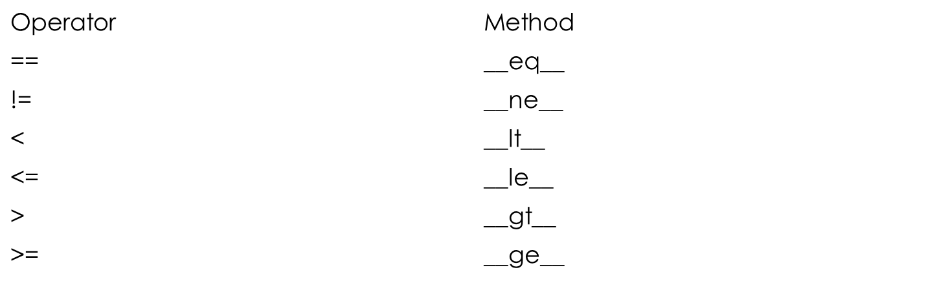

SUBCLASS TABLE (derived from Furniture):

Add an additional public attribute **wood** that represents the material the table is made from.

Add a constructor that takes two parameters: weight in lbs and wood.

Should throw an exception if weight is less than or equal to 0

or wood argument is not a string

(*Hint: you can use the* ***isinstance*** *built-in function to check the class of the argument to be* ***str****)*

Add a **__str__()** method that returns a string that says:

“Table Item Weight: *weight* Made of: *wood.*”

value of *weight* comes from its **weight** property

value of *wood* comes from its **wood** property.

This method should use the string returned by the base class **__str__** method.

3) BED SUBCLASS (derived from furniture)

Add a public attribute size that represents the size of the bed.

Allowed values: “Twin”, “Full”, “Queen”, and “King”

Add a constructor that takes two parameters: weight in lbs and size.

The constructor should throw an exception if weight is less than or equal to 0

or size argument is not one of the allowed values.

Add a **__str__()** method returns a string that says: “Bed Item Weight: *weight* Size: size”

where the value of weight comes from its **weight** property

value of size comes from its **size** property

This method should use the string returned by the base class **__str__** method.

FURNITUREGALLERY

Add a private attribute called **__furnList** which is a list of **Furniture** class (and derived classes) objects.

Add a constructor with no arguments that initializes the **__furnList** to empty list.

Add a method called **addFurniture** that takes an argument which is supposed to be a Furniture class (or derived class) object.

Method should verify that the argument is one of the Furniture or derived classes and add it to **__furnList.**

Add a **sort** method that sorts the **__furnList** list based on weight.

Make this class iterable so that it can be used in a for-loop to iterate over the objects in the list.

(What special method do you need to add here?)

ANSWER: __iter__() and __next__()